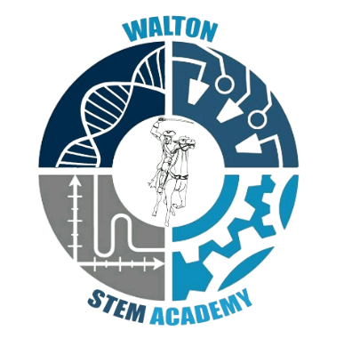

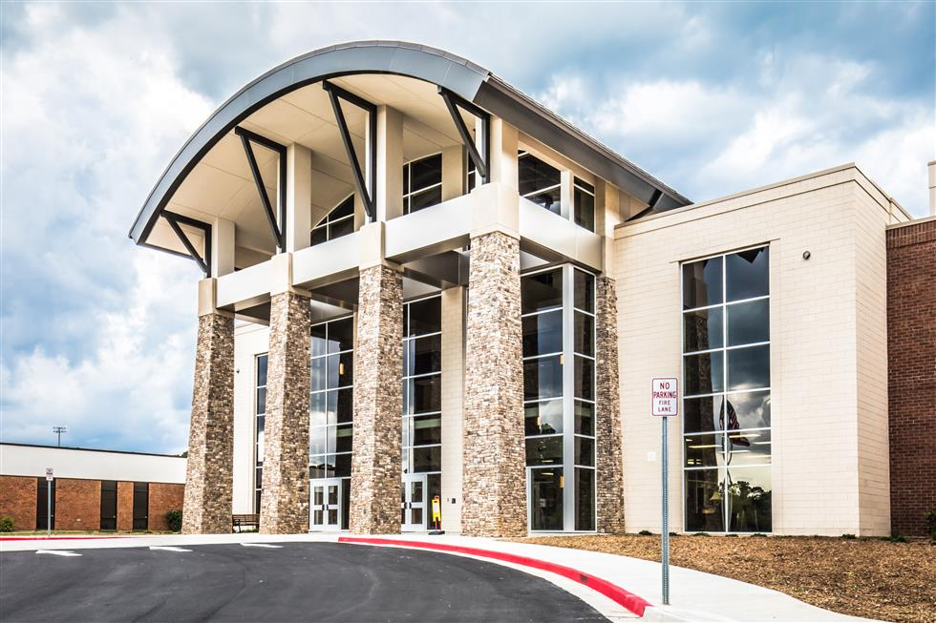

**Walton High School STEM Academy Handbook**

**Website:** [**https://www.waltonstem.com/**](https://www.waltonstem.com/)

Table of Contents

**Topic Page Number**

Walton STEM Academy’s Guiding Principles 3

Welcome 4

From the Director 5-6

STEM Academy Leadership 6

General Information 7

Program Description 8

Advanced Math and Science 9

Biomedical Sciences 9-10

Engineering 10-11

Eligibility Requirements 11

Admissions Process 12

Continuing Eligibility Requirements 12

Academic Standards 12

STEM Requirements for all Pathways 12-14

Other Opportunities 14-16

Extra Help 16

Withdrawal Policy 16-17

Appeal to Withdraw 17

Readmission Appeal 17

Appendix A: Curriculum Guide 18-26

Appendix B: Walton STEM Academy Code of Conduct 27-31

Appendix C: Withdrawal Form 32

Appendix D: Competition Hints and Suggestions 33-40

Appendix E: Internships 41

Appendix F: Probation 42-43

Walton STEM Academy’s Guiding Principles

**Vision**

Engage. Inspire. Empower.

**Mission**

Foster student curiosity in science, technology, engineering, and mathematics, to cultivate joy in learning and build the confidence to engage as ethical leaders capable of addressing the world’s most significant issues.

**Statements of Purpose**

* To develop strong interpersonal, communication, research, and technical skills necessary to compete in an ever-changing global society.
* To establish high academic, social, and ethical expectations.
* To foster mastery of both knowledge and skills utilizing innovative resources and authentic experiences.
* To collaborate and cooperate locally and globally within the STEM community.
* 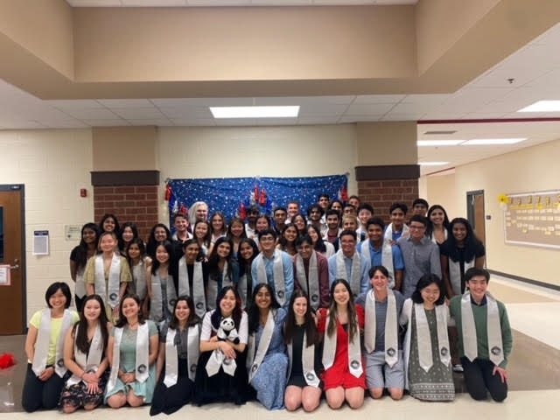To build partnerships with community stakeholders which will strengthen our program and enhance the lives of our students.

**Class of 2022**

Welcome to Walton’s STEM Academy!

From our Team

Welcome! We are glad you have chosen to be a part of our STEM academy and look forward to the next four years as you move through your pathway. Our foremost goal is that you have an outstanding experience in the program. As such, we have designed this handbook to provide information and details that should prove useful to you and your family.

The Walton Team is committed to providing you with the best possible education. We want you to take advantage of all the opportunities being a member of our academy offers. Immerse yourself in the benefits of a cohort as well as the larger student body. Become engaged in both the academic and extracurricular programs and the larger community. Let the world inspire you as you learn to look at things with different lenses, and then, inspire others. Use what you learn and the tools you gain to make the world a better place.

In doing so, act ethically, using your moral compass to determine what is right, what is wrong, what is just, what is unjust, what is good, and what is bad. You don’t have to do something extraordinary to make a difference. Your actions can be as simple as making someone feel special or just listening to someone who needs to talk. The fact is that you’ll be changing the world one good deed at a time. Of course, no one will complain if your actions are extraordinarily world changing! All we ask is that you do your best. We are excited to be part of your journey!

Sincere regards,

Walton STEM Faculty

From the Director

Dear Parents,

This may be your first child to enter high school, or you may be a parent well experienced with the world of high school, but as both the STEM director and the parent of a Walton graduate, I would like to offer a few suggestions.

One of the most frequent question I get is, “What does a schedule look like for STEM students? Do they have time for extracurriculars?” This is a loaded question that does not have one simple answer.

In answering this question, I would begin with this: You know your child better than anyone. What can they handle?

The transition from middle school to high school can be challenging for students. The student’s level of organization, motivation, and self-confidence make a substantial difference in this transition. High school is much more “hands-off” compared to middle school. The students are expected to keep up with due-dates, know how to budget their time, know how to study, know how to take notes, know how to find information and ask questions, etc. Some students come with these skills already in place and some must quickly figure them out.

First, let me discuss stress. All STEM classes are at the honors or AP level. Students may need time to adjust to the pace and depth of these classes. Typically, the more organized a student is, the easier the adjustment. There is tension between memory and new learning and moving from concrete thinking to abstract thinking. While I won’t get into the learning theory, the stress is real. It is not unusual that there are moments of high stress in a student’s academic life, for example, tests and exams, but each day should not be at that same level. Some stress is good but too much can be detrimental to both physical and mental health. Finding a balance is key. Making sure students are getting enough sleep, eating well, and exercising is probably one of the most common challenges parents of high school students face! I wish I had a quick fix for this, but the only advice I have is to “pull rank”: exert your influence as their parent and force them to take breaks for meals and exercise.

Second comes the task of helping students persevere when the challenges arrive. These times will be specific for each student, it may be honors biology, AP chemistry, or advanced geometry and algebra II, but the challenges will come. Most STEM students are used to getting A’s on everything, many without having to work too hard to get those A’s. Setting realistic expectations and supporting students during this period of growth can help students learn appropriate coping strategies. There are a number of opportunities provided by the school to help students such as WEB and honor society tutors, teacher office hours, etc. I can tell you from own family’s experience there were tears of frustration, self-pity, anger, as well as utter joy! The first 100% on a math test was equivalent to a national holiday in our house!

Next, helping students advocate for themselves is a life skill that goes well beyond high school. If a student does not understand something, wants to go over an assignment, needs extra help, wants to know about a certain grade, etc., it is important that they have the ability to talk with their teachers. Teachers understand that talking to them can be intimidating for some students, if they do not want to talk with a teacher during class in front of their peers, they can find a time between classes or before or after school. But, and this is a serious but, not talking to their teachers should not be an option. In most situations, before a teacher hears from a parent, they should have heard from the student.

It is also important that if a parent has a question or concern, that they reach out to the teacher. After having sat through a number of parent/teacher conferences, I often find the situation could have been addressed much earlier by just contacting the teacher for more information. Just as you must make decision for the entire family, teachers make decisions for entire classes of students. Sometimes a student may not understand the decision (or agree with it) but they are not privy to the whole picture. We are contradictory creatures that like guidelines and rules, until they apply to us! In closing, I am here to assist you and your student if issues arise. I, along with the leadership team, wish you much success during your years in the STEM Academy.

Sincere Regards,

Dr. Tina Link

**STEM Academy Leadership**

STEM Director – Dr. Tina Link [tina.link@cobbk12.org](mailto:tina.link@cobbk12.org)

Admissions Coordinator – Mr. Joe League [joseph.league@cobk12.org](mailto:joseph.league@cobk12.org)

Outreach Coordinator – Ms. Tobie Hendricks [Tobie.hendricks@cobbk12.org](mailto:Tobie.hendricks@cobbk12.org)

STEM Assistant Principal – Ms. Pam Lavangie [Pamela.lavangie@cobbk12.org](mailto:Pamela.lavangie@cobbk12.org)

Student Leadership Team – the student leadership team is composed of students in grade levels 10th through 12th from each pathway. Students may apply to become a member of the leadership team during the second semester of their freshman year. Once selected, students serve until they graduate.

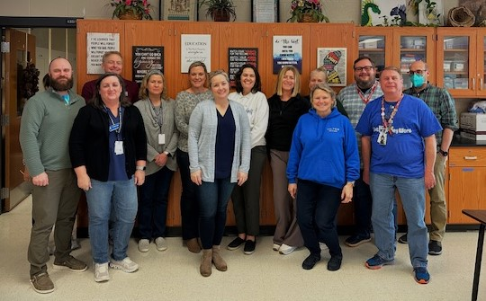

General Information

**Why STEM?**

According to Maria Norris of Study in the USA, each STEM component brings a valuable contribution to a well-rounded education. Science gives learners an in-depth understanding of the world around us. It helps them to become better at research and critical thinking. Technology prepares young people to work in an environment full of high-tech innovations. Engineering allows students to enhance problem-solving skills and apply knowledge in new projects. Mathematics enables people to analyze information, eliminate errors, and make conscious decisions when designing solutions. STEM education links these disciplines into a cohesive system. Thus, it prepares professionals who can transform society with innovation and sustainable solutions.

With all of that said, STEM programs are not meant to take away from other academic disciplines but fold them into a larger landscape. Understanding historical and political contexts and learning from our past is essential if we want to build community and avoid continuing to make the same mistakes; reading and interpreting various types of text can provide unique frameworks of thought as well as develop analytical skills; writing concisely and communicating appropriately enhance not only our professional life but our personal life. STEM fields provide a platform to showcase all academic disciplines.

Halloween is a big deal at Walton!

**Program Description**

The Walton High School Science, Technology, Engineering and Mathematics (STEM) Academy offers students a rigorous curriculum driven by problem solving and discovery in a student- centered environment. The Walton STEM Academy pairs two classes together for each cohort. The cohort model allows students to be a part of a unique and consistent group of students, building a strong social and emotional support system as well as developing long-term collegial relationships. The rest of the student’s courses are selected from those offered to the entire student population. Walton has a long history of student success and a strong general curriculum and fine arts program. This allows the STEM students the opportunity to explore diverse interests with their peers.

In accordance with the Georgia Department of Education STEM goals, the Walton STEM Academy will:

1. Instruct through rigorous and relevant curriculum
2. Empower students to become innovators and technologically proficient problem solvers
3. Ensure that all students have access to the appropriate technology conducive to enhancing their STEM learning experiences both in and outside the traditional classroom
4. Nurture partnerships that allow schools and the business sector to join efforts to improve students’ STEM-career opportunities
5. Increase the number of students pursuing careers in STEM-related fields and/or post-secondary STEM related education/training

The Walton STEM academy is designed for students who have a desire and passion to pursue one of three majors: Advanced Science and Mathematics, Biomedical Science, or Engineering. Students accepted to the STEM academy will take 4 years of their major along with 4 honors and/or AP science courses.

Students are admitted into the specific STEM academy major in their freshman year. Acceptance of admission into Walton’s Science, Technology, Engineering and Mathematics Academy implies that a student will remain an Academy student throughout their high school career in order to earn STEM designation on their Walton diploma. Special sections of STEM classes are hand-scheduled for students to obtain the best possible scenario for success. Teacher allotments do not allow for flexibility once courses are established. So please make your considerations carefully and submit an application if you are genuinely serious about your major.

Each major within the STEM Academy focuses on a particular interest of the student; therefore, the admission standards and course sequences differ. The following provides information regarding expectations of each major.

A description of the STEM classes can be found in Appendix A.

**The Pathways:**

**Advanced Mathematics and Science**

The Advanced Mathematics/Science student is curious about math and science beyond the classroom. The student is able to see relationships between and among topics intuitively and recognizes the symbiotic relationship between math and science. The student has a strong work ethic and understands that teamwork is an essential part of success because the creative minds of many outperform the individual.

*Students who wish to apply to the STEM Advanced Mathematics/Science Academy must be recommended for Accelerated Geometry/Advanced Algebra and Honors level Science.* Students accepted in this major will take 4 years of advanced Mathematics and 4 AP Science courses. The following information table outlines the projected Advanced Mathematics/Science courses. *This table serves as a guide to inform students and parents of the general course direction to achieve the STEM Advanced Mathematics/Science endorsement and is subject to change in order to accommodate the needs of the school and personnel.*

|  |  |  |  |
| --- | --- | --- | --- |
| 9th Grade | 10th Grade*** | 11th Grade | 12th Grade |
| Enhanced Honors Geometry A&B/Enhanced Honors Advanced Algebra A&B* | STEM AMS AP Precalculus BC (embedded with Advanced Finite Mathematics) * | AP Calculus BC | Multivariable Calculus or Distance Calculus with Georgia Tech |
| AP Environmental Science | AP Chemistry | AP Physics C | AP Biology |
|  |  | AP Seminar | AP Research |

* Students will receive two credits for these courses.

Students are encouraged to take AP Statistics as an additional class during 10th or 11th grade.

**Students will work with their AP Biology teacher to develop and complete the senior research project. Applies only for student in classes 2023-2025.

***Students will have the option of signing up for STEM AP Computer Science in the 10th grade with the objective of taking three years of AP and post-AP Computer Science courses.

**Biomedical Sciences**

The biomedical student has as interest in pursuing a career within the medical field.  Because of the embedded on- and off-campus internship opportunities within this pathway, the foundation of this interest is based on the student’s enjoyment in helping people.  The biomedical student must be responsible and motivated by knowing they can make a difference in the lives of others.  The student must be able to work independently and as a team member in promoting health and wellness.  The student must be able to both think critically and to formulate a solution or series of solutions related to various health issues.  The biomedical student is excited about medicine, how it changes and the endless possibilities of new discoveries.  The Biomedical Science courses use Project Lead the Way curriculum which is national recognized for excellence.

Students who wish to apply to the STEM Biomedical Science Academy must be recommended for at least GSE Honors Algebra and Honors level Science.  Students accepted in this major will take 4 years of biomedical science courses and 4 honors & AP Science courses.  The following information table outlines the projected courses for a Biomedical Sciences major.  *This table serves as a guide to inform students and parents of the general course direction to achieve the STEM Biomedical Sciences endorsement and is subject to change in order to accommodate the needs of the student, school and personnel****.***

|  |  |  |  |
| --- | --- | --- | --- |
| 9th Grade | 10th Grade*** | 11th Grade | 12th Grade |
| PLTW Principals of Biomedical Science | PLTW Human Body Systems **and** Honors Human Anatomy* | PLTW Medical Interventions | PLTW Capstone: Biomedical Innovation** **and** STEM Advanced Scientific Research IV* |
| Honors Biology | Honors Chemistry | AP Biology | AP Physics 1 or C |

*Students will receive two credits for these courses. 10th grade: Students will receive an honors credit for the PLTW course and the same grade will also count as Honors Human Anatomy. 12th grade: Students will receive a credit for PLTW BI and a post-AP credit for STEM Advanced Scientific Research IV. Research IV is a post Advanced Placement class embedded in the capstone course and students will receive an extra quality point in their GPA based on their PLTW capstone grade.

**Students will complete the senior research project as part of this course.

***Students will have the option of signing up for STEM AP Computer Science in the 10th grade with the objective of taking three years of AP and post-AP Computer Science courses.

**Engineering**

The Engineering student has a natural curiosity for how things work. The student is able to apply creative solutions to problems that may not have concrete answers. The engineering student enjoys math and science and seeing how these subjects apply to problems. Additionally, the student understands that brain power alone is not enough to be a successful engineer and student, but hard work in class and meeting assignment deadlines is essential. The student must understand that teamwork is an essential part of engineering because the creative minds of many outperform the lone genius. The engineering student is enthusiastic about engineering whether it is for one particular field or the aspect of problem solving as a whole. The Engineering courses use Project Lead the Way curriculum which is national recognized for excellence.

Students who wish to apply to the STEM Engineering Academy must be recommended for at least GSE Honors Algebra and Honors level Science. Students accepted in this major will take 4 years of Engineering courses and 4 honors & AP Science courses. The following information table outlines the projected courses for an Engineering major. *This table serves as a guide to inform students and parents of the general course direction to achieve the STEM Engineering endorsement and is subject to change in order to accommodate the needs of the student, school and personnel.*

|  |  |  |  |
| --- | --- | --- | --- |
| 9th Grade | 10th Grade | 11th Grade | 12th Grade |
| PLTW Introduction to Engineering Design | PLTW Principles of Engineering | PLTW Aerospace Engineering or PLTW Digital Electronics  (Course alternates every other year) | PLTW Capstone: Engineering Design and Development** **and** STEM Advanced Scientific Research IV*** |
| Honors Biology | Honors Chemistry | AP Physics 1/C: Mechanics**** | AP Physics C: Electricity and Magnetism |

*Students will have the option of signing up for STEM AP Computer Science in the 10th grade with the objective of taking three years of AP and post-AP Computer Science courses.

**Students will complete the senior research project as part of this course.

***Students will receive two credits for this course. Students will receive a credit for PLTW EDD and a and a post-AP credit for STEM Advanced Scientific Research IV. Research IV is a post Advanced Placement class embedded in the capstone course and students will receive an extra quality point in their GPA based on their PLTW capstone grade.

****Dependent on their level of math, students can choose between AP Physic 1 and AP Physics C.

Note that the 11th grade engineering course alternates between PLTW Digital Electronics and PLTW Aerospace Engineering. If the 11th grade course is Digital Electronics (or alternatively Aerospace) and a student would like to take Aerospace (or alternatively Digital Electronics), they may do so as an elective in either their junior or senior year. This would not be considered a requirement for the pathway but out of consideration for the student’s interest.

**Eligibility Requirements**

In order to participate in the Walton STEM Academy, students must:

1. Complete the application by the due date, taking thoughtful consideration when selecting the pathway and answering the essay questions.
2. Request recommendations from current Language Arts, Science, and Math teachers.
3. Be recommended for the appropriate honors level courses for the pathway.

* Students who wish to apply to the STEM Advanced Mathematics/Science Academy must be recommended for Accelerated Geometry/Advanced Algebra 2 and Honors level Science.
* Students who wish to apply to the STEM Biomedical Sciences or Engineering pathway must be recommended for at least GSE Honors Algebra and Honors level Science.
* **Note:** These requirements must be met through the 8th grade teacher’s recommendation and not through summer school attendance. For example, a student has applied for the Advanced Math and Science pathway which requires that the 8th grade math teacher recommend the student for Advanced Geometry/Alg. 2. The student is recommended for Honors Alg. 1 but decides to take Honors Geometry A in the summer in order to be eligible for Accelerated Geometry/Advanced Alg. 2 as a freshman. Because the student was not recommended by the 8th grade teacher for this class, the student is not eligible to be in the AMS pathway.

**Admissions Process**

The Admissions Coordinator collects academic data (standardized test scores, middle school transcripts, etc.), ensures that all components of the application are present, and creates a file for each applicant. The admissions committee convenes in late January to review applications. Two to three committee members look at each application, completing a rubric. Once scores are tabulated, the STEM admissions committee and the STEM Leadership determine the cut off score for each pathway. This is based on the quality of the applicants and the number of students that can be supported in each pathway.

Admissions decisions are mailed in February.

Intent letters and contracts returned to school by March deadline.

**Continuing Eligibility Requirements**

Students admitted to the STEM Academy must continually meet the following criteria in order to remain in the Academy (refer to the STEM Academy Program Contract):

* **Academic Standards**

1. STEM students must earn a minimum grade of 80 in each required STEM course to maintain a “good standing” status.
2. If a student receives a grade below an 80 in any required STEM course, he/she will be placed on academic probation through the following semester.

***Dismissal*** from the program may result if a student a student earns a grade below an 80 in any required STEM course for two semesters in a row. Or if the student earns a grade of D (below a 73) in any required STEM course in any given semester.

* **Ethical and Integrity Standards**
  + Maintain the guidelines set forth in the STEM Academy Code of Conduct (see Appendix B).

**STEM Requirements for all Pathways:**

* **STEM Academic Competition Requirements for 9th and 10th Grade:** Involvement in a school sponsored individual or group competition. For example, HOSA, Math Team, Science Olympiad, and Robotics.

Students admitted into the STEM Academy are required to participate in a STEM club with a competition component or an outside competition which requires commitment and preparation and includes a mentor’s oversight. While this is only required in the 9th and 10th grade, we hope that students find a club or competition that challenges and inspires them enough to continue throughout their high school experience.

Why do we have this requirement? Well, there are several reasons.

1. Early integration into high school – High school is very different from middle school and as such, forming new friendships and support groups is a significant part of success with the transition. While the cohort model allows for these friendships within the group, we want the students to be able to interact with other students that may not be in the STEM academy but still have the same interests for a STEM area.

Research indicates that participation in extracurricular activities positively correlates with students’ development both academically and personally. Students who participate in extracurricular activities have greater academic success, greater character development, especially in the areas of time-management and leadership skills, more positive social development, the ability to accept constructive criticism. and greater interest in community involvement.

Christison, C. (2013) The Benefits of Participating in Extracurricular Activities. *BU Journal of Graduate Studies in Education 5(2).*

1. STEM academic competitions allow students the chance to experience and use STEM content in a real-world context beyond what they get in the classroom. Additionally, STEM competitions allow students to develop their skills in their areas of interest while gaining valuable insight into their talents and preferences.
2. Colleges want to see that students in STEM areas are interested enough to use their own time to pursue the things they are interested in and can commit to long-term endeavors.

Your participation in STEM/academic clubs can prove very consequential especially if you take on successfully increasing responsibility. Participation can hone your communication skills, foster creative thinking, and teach you how to work effectively with other people. Your extracurricular involvement is one of the few ways that colleges can gain insights into your personality. Extracurriculars can take a lot of time—and because your time in high school is precious—colleges recognize this level of commitment. Colleges receive thousands of applications each year, and students need more than high GPAs and SAT scores to stand out from the pack.

**Note:** Any competition that is part of the STEM classes curricular requirements DO NOT count as one of the required competitions. For example:

* Advanced Math and Science students are required to take the AMC each year as part of the math curriculum, this does not count as one of their required competitions.
  + While not required, BMS and ENG students should consider taking the AMC. This ***does not*** count as one of the required competitions.
* Engineering students participate in the Inventure Competition as part of the curriculum in the STEM Engineering Honors Chemistry course, so this does not count as one of the required competitions.

See Appendix D for a list of helpful hints and competition suggestions.

* **Summer of 11th grade-12th grade: a 40-hour internship in a STEM related area.** This could include a camp, Governor’s Honors Program (GHP), shadowing a professional, etc. This requirement is flexible but must be STEM related. If a student has a question about a possible internship opportunity, they need to discuss it with the director.
* **12th grade: students must take part in a cumulative research project from the perspective of their major.** (See Appendix E)
  + The senior Engineering Design and Development course for engineering and the senior Biomedical Innovation course for the biomedical pathway fulfill this requirement.
  + The senior AP Research course for advanced math and science fulfills this requirement.
* **Annual participation in Walton’s STEM Expo in January** 
  + Students will work with their STEM classes to determine the method of participation. Students may participate in the Science Expo in more than one activity each year.
    - Science Fair
    - Community Outreach/Activities
    - Club Participation
    - Informal Presentations of Projects
    - Senior Research Project Presentations
* **Lunch and Learns** 
  + 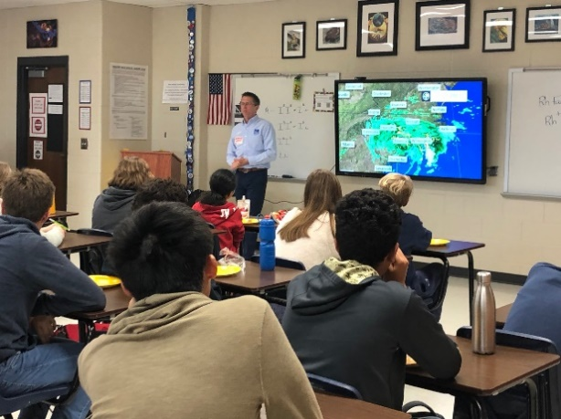Approximately two times per semester, the STEM Academy arranges for Lunch and Learns. These are unique opportunities for students to hear from professionals in the STEM fields. During each of the lunch periods, students listen to a guest speaker presents their work while eating lunch provided by the academy*.*

Dr. Richard Knabb, Hurricane Specialist with the Weather Channel

* + *Attendance is required and students must sign-in.*
* 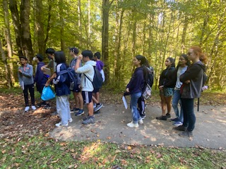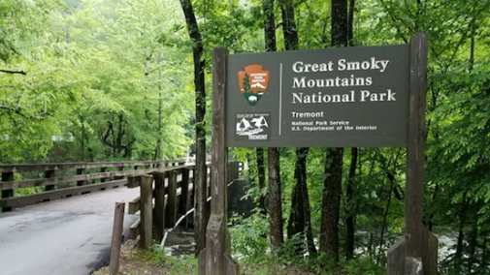**Other Opportunities**

**Travel**

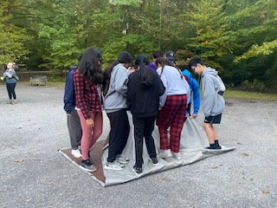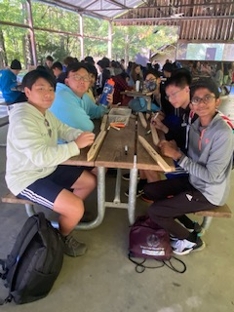**Tremont:** An annual trip for incoming freshman. A chance to meet the freshman class cohort and spend some time bonding and exploring nature!

**International Travel**

The STEM Academy has partnered with EF Tours to provide unique travel experiences for our STEM students. Freshman and sophomores have the opportunity to visit Panama and learn about the unique ecology of Panama as well as the history and engineering achievement of the Panama Canal. Juniors and Seniors have the opportunity to travel to Europe to explore various countries STEM contributions.

Note: The location of trips will change based on the year.

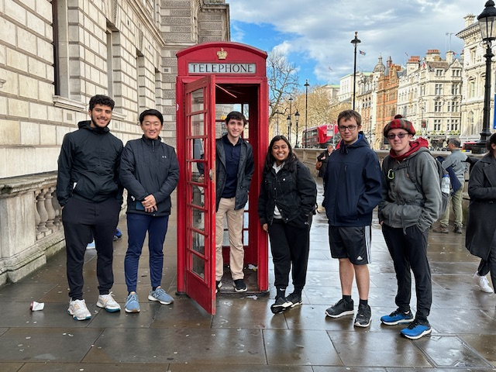

Ship passing through the Panama Canal

Scotland and England

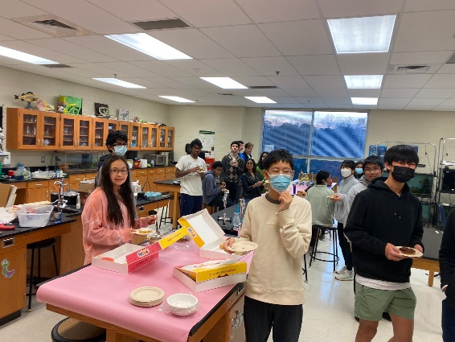

**Local Fun**

**Breakfast** Each semester, student leadership hosts a breakfast for the students.

**Fall Potluck**

In the fall, the STEM Academy hosts a Potluck dinner for all STEM students and their families.

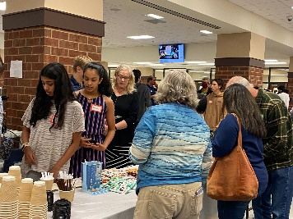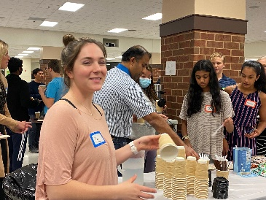

**Spring Picnic**

Join us at East Cobb Park in the spring for a cookout and games!

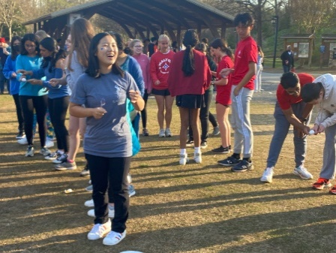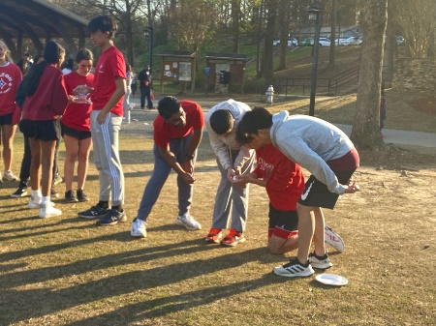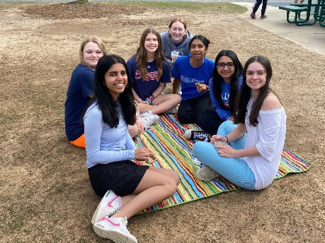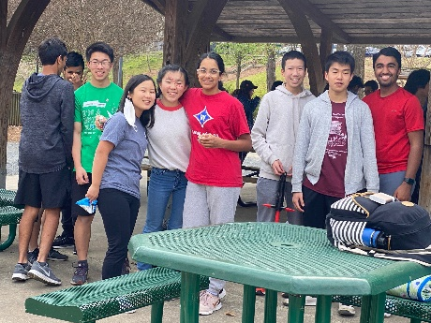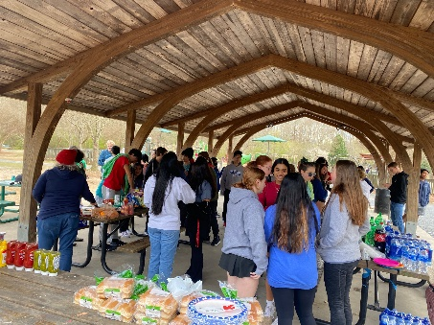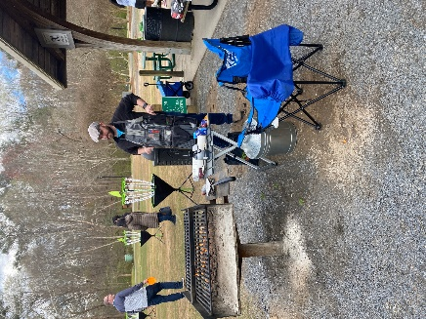

**Extra Help**

If you are struggling in any of your classes (STEM or non-STEM), Walton has a number of options that we encourage you to try:

1. Teacher’s office hours: All teachers have office hours open to students for extra help. Talk with your teacher and let them know you would like to come and pick a good time appropriate for you both.
2. WEB: This time was designed specifically to allow students to meet with teachers and/or peers and get extra help.
3. Honor societies – Walton has several honor societies that offer free tutoring services. Students may request a tutor by going to Walton’s home page and under the “Student” tab, selecting “Student Tutoring Program.” <https://www.waltonhigh.org/domain/70>
4. Visit your guidance counselor. The counselors can offer many different strategies to help you navigate the world of high school.

**Withdrawal Policy**

We recognize that we are asking 8th grade students, most without a lot of experience in a chosen pathway, to commit to a four-year program. It is understandable that a student may begin in a pathway and decide that they are not interested in that field. The decision to leave the STEM Academy requires serious consideration. In a competitive application process, each student choosing the academy has taken one of the available slots that may have been available to another student. In addition, staffing decisions are made based on student enrollment.

Prior to making the decision to withdraw from the academy, keep in mind:

Balance: How many academic courses are you taking and at what level? Your priority should be your STEM classes. That may mean you need to look at your other classes and reduce the level or change the course. For example, instead of taking all, or most, classes at the AP level, consider some of the courses at the honors level.

Is your consideration based on one class? Work through the class! Don’t make the decision to leave the academy based on the struggle in one course. The odds are that no matter what you must take in school, one of those classes will either be difficult, or you just don’t care for it.

If you are struggling, talk to your teacher. There are a number of options available for extra help, both academically and emotionally, so reach out. Our primary goal is your success.

**Appeal to Withdraw from the Academy**

Should the student make the decision to withdraw from the Academy, the student will need to fill out the withdrawal form including both the student’s and parent’s signature, Appendix C, and submit it to the STEM director. Once the form is submitted the student will meet with the STEM director. If the decision remains to withdraw, the form will be sent to the guidance counselor for a schedule change. When the schedule change occurs will be determined by time of year, availability, and type of current course.

Appendix A

**Curriculum Guide**

**Science, Technology, Engineering, and Mathematics (STEM) Academy**

The STEM Academy provides a rigorous program of study for students who have a sincere interest in the STEM fields. The academy provides three pathways: advanced math and science, biomedical sciences, and engineering. The academy's mission is to provide students a rigorous, interdisciplinary learning environment focused on science, technology, engineering and mathematics, to foster curiosity, and to promote a collaborative culture of ethical and innovative problem-solving. *Students must apply in the fall of the 8th grade year.  Student accepted into the academy will take 4 years of paired STEM courses unique to each pathway.*

***Placement into the following courses requires admission into the STEM Academy. Admission occurs prior to the 9th grade year.***

**ADVANCED MATH AND SCIENCE PATHWAY**

**STEM AP Environmental Science A&B**  **For grade 9**

The Advanced Placement Environmental Science course is designed to be the equivalent of an introductory Environmental Science course at the college level.  The goal of the course is to provide students with the scientific principles, concepts, and methodologies required to understand the interrelationships of the natural world, to identify and analyze both natural and human made environmental problems, to evaluate the relative risks associated with these problems, and to examine alternative solutions for resolving or preventing them.  Environmental science is interdisciplinary; it embraces a variety of topics from biology, chemistry, geology, and public policy.  The course has significant laboratory and fieldwork components.  The course prepares students to take the AP Environmental Science exam.

**Enhanced Honors Geometry A&B/Enhanced Honors Advanced Algebra A&B For grade 9**

This course includes the same topics of study included in Geometry and Advanced Algebra but places more emphasis on formal processes, rigor, critical thinking, and analysis of mathematical concepts.  It conforms to Georgia’s K-12 Mathematics Standards of Geometry and Advanced Algebra.  Students taking this course must complete a summer packet that is due on the first day of school. Students will take the full Honors Geometry course fall semester and the full Honors Advanced Algebra course spring semester. The STEM class dives deeper into proofs and applications of concepts throughout the curriculum while incorporating topics from the AP Environmental Science course.

**STEM AP Chemistry A&B\*\*\*** **For grade 10**

AP Chemistry is a college level introductory course in chemistry for those intending to major in a science related field.  Materials studied in this course also include the topics, concepts, and laboratory experiments associated with first-year college chemistry and extensive mathematical applications of laws learned in the first-year course.  The goal of AP Chemistry is to develop critical thinking skills and improve reasoning regarding topics in chemistry.  Topics to be studied include atomic theory and structure, chemical bonding, organic chemistry, gases, liquids, solids, solutions, types of reactions, stoichiometry, equilibrium, kinetics, and thermodynamics.  This course prepares students to take the AP Chemistry exam.

**STEM AP Precalculus**  **For grade 10**

AP Precalculus centers on functions modeling dynamic phenomena. This research-based exploration of functions is designed to better prepare students for college-level calculus and provide grounding for other mathematics and science courses. In this course, students study a broad spectrum of function types that are foundational for further study in the STEM disciplines.

Throughout this course, students develop and hone symbolic manipulation skills, including solving equations and manipulating expressions, for the many function types throughout the course. Students also learn that functions and their compositions, inverses, and transformations are understood through graphical, numerical, analytical, and verbal representations, which reveal different attributes of the functions and are useful for solving problems in mathematical and applied contexts. In turn, the skills learned in this course are widely applicable to situations that involve quantitative reasoning.

Students understand functions and their graphs as embodying dynamic covariation of quantities, a key idea in preparing for calculus. With each function type, students develop and validate function models based on the characteristics of a bivariate data set, characteristics of covarying quantities and their relative rates of change, or a set of characteristics such as zeros, asymptotes, and extrema. These models are used to interpolate, extrapolate, and interpret information with different degrees of accuracy for a given context or data set. Additionally, students also learn that every model is subject to assumptions and limitations related to the context. As a result of examining functions from many perspectives, students develop a conceptual understanding not only of specific function types but also of functions in general.

In addition to the prescribed AP Precalculus curriculum, students in STEM BC Precalculus will:

* Use complex numbers in trigonometric form
* Understand and use vectors in 3-space
* Use dot product and cross-product to solve problems
* Use sequences and series beyond arithmetic and geometric patterns
* Explore parametric representations of plane curves in 2- and 3-space
* Explore matrices and use matrices in applications
* Use the binomial theorem to calculate probability and expand binomials
* Explore set theory
* Develop the use of proofs, including direct proofs, indirect proofs and proof by induction
* Enhance the understanding of rational functions using partial fraction decomposition
* Explore the foundation of graph theory

**STEM AP Physics C - Mechanics A&B For grade 11**

The Advanced Placement Physics C course is a calculus-based, in-depth study of mechanics.  The course is an investigation driven development of the laws of physics.  Problem-solving and critical thinking are emphasized throughout the course.  The topics of kinematics, dynamics, impulse and momentum, work and energy, rotational motion, oscillations and gravitation are covered in this course.  This course ordinarily forms the first part of the college sequence that serves as the foundation in physics for students majoring in science, applied science, and engineering.  This course prepares students to take the AP Physics C exam in mechanics.

**STEM AP Calculus BC For grade 11**

This course conforms to the College Board topics for the Advanced Placement Calculus BC Examination.  Topics covered include functions (including parametric, polar and vectors), graphs, limits, derivatives, integrals, polynomial approximation and series. The STEM AP Calculus BC class follows the framework distributed by the College Board while incorporating proofs, applications, and additional calculus topics found outside the framework. The students are required to complete multiple projects that further enhance learning of calculus topics. This course prepares students to take the AP Calculus BC exam.

**AP Capstone Courses**

Students graduating in 2026 and on will be required to take AP Seminar and AP Research. This will make students eligible for the AP Capstone Diploma and fulfill the senior capstone requirement. Current freshmen and sophomores are encouraged to enroll in these courses during their junior and senior years. If current students are unable to enroll in these courses, they will need to work with their AP Biology teacher to ensure that they meet the capstone requirements outside of the classroom.

T*o earn the AP Capstone Diploma, students must score a 3 or above on both the AP Seminar and AP Research exams as well as a 3 or above on four other AP exams of their choosing.*

**STEM AP Seminar For grade 11**

In AP Seminar students will engage with complex academic and real-world issues, examining them through multiple lenses and considering multiple viewpoints.  The topics may change from year to year depending on student and teacher interests, global and civic issues, academic questions, and concepts from other AP courses.  Students will evaluate multiple viewpoints through several of the following lenses:  cultural and social, artistic and philosophical, political and historical, environmental, scientific, futuristic, and ethical.  Through inquiry and investigation, students will develop their own perspectives on complex issues and topics while honing their critical and creative thinking skills.  During the course, students will complete a team research project and presentation, an individual research project and presentation, and an end of course exam in which they will analyze, compare and synthesize arguments.

**STEM AP Biology A&B For grade 12**

The Advanced Placement Biology course is designed to be the equivalent of a college introductory biology course usually taken by biology majors during their first year.  The AP course in biology differs significantly from the usual first high school course in biology with respect to the kind of textbook used, the range and depth of topics covered, the kind of laboratory work done by students, and the time and effort required of students.  It provides students with the conceptual framework, factual knowledge, and analytical skills necessary to deal critically with the rapidly changing science of biology.  Specific topics covered include biological chemistry, cells, energy transformations, molecular genetics, heredity, evolution, classification. and organ systems, bacteria, protista, fungi, plants, animals and ecology.  This course also prepares students to take the AP Biology exam. Students must be available for WEB labs and there will be a required summer assignment.

**STEM Multivariable Calculus For grade 12**

This course is a continuation of calculus and includes topics such as vectors, vector functions, partial derivatives, multiple integrals and vector calculus. *Note: Students may apply for and if accepted, take Georgia Tech’s Distance Calculus in lieu of multivariable.

**STEM AP Research For grade 12**

AP Research allows students to deeply explore a STEM topic, problem or issues of individual interest.  Through this exploration, students design, plan and conduct a year-long research-based investigation to address a research question.  In the AP Research course, students further their skills acquired in the AP Seminar course by understanding research methodology; employing ethical research practices; and accessing, analyzing, and synthesizing information as they address a research question.  Students explore their skill development, document their processes and curate the artifacts of the development of their scholarly work in a portfolio.  The course culminates in and academic paper of approximately 4000-5000 words (accompanied by a performance or exhibition of product where applicable) and a presentation with an oral defense. AP Statistics is strongly recommended.

**BIOMEDICAL SCIENCES PATHWAY**

**STEM Biology A&B Honors**  **For grade 9**

Honors Biology explores basic biological processes. Topics of study include inorganic and organic chemistry principles, cell structures and function, cellular processes, cellular respiration, photosynthesis, and cellular reproduction, genetics, and DNA, evolution, biological diversity and its classification, and biotechnology. Honors Biology is a laboratory-based class. Students will be involved in computer-based and traditional lab activities with an emphasis on collaborative inquiry exploration. STEM students will work on a year-long project determined by the instructor. Students will take the state Georgia Milestones EOC at the end of the course.

**STEM PLTW Principles of Biomedical Science A&B Honors For grade 9**

Principles of Biomedical Science uses the PLTW curriculum. This honors course requires students to design research strategies, analyze data related to outbreaks and healthcare as well and explore clinical empathy and health promotion. Students will develop technical skills using cutting edge technologies as well as skills involving problem solving, critical and creative thinking, communication, and collaboration. Students will take the PLTW end-of-course test.

**STEM Chemistry** **A&B Honors For grade 10**

Honors Chemistry is a laboratory-investigation based science class studying matter & its changes. Topics covered include periodic trends, bonding, molecular shape, polarity, chemical reactions, intermolecular forces, acids & bases, equilibrium, stoichiometry, gas relationships, electrochemistry, & energy changes. This class emphasizes analysis & application of course content. Math-based reasoning is regularly used to predict & explain data. Students describe Honors Chemistry as interesting & fun.

**STEM PLTW Human Body Systems A&B Dual Honors For grade 10**

Human Body Systems combines the PLTW curriculum with Honors Anatomy and Physiology. This course is designed to introduce students to the structure and function of the human body through a study of the 11 organ systems.  The class will concentrate on three themes of study– interrelationships of body organ systems, homeostasis and complementarity of structure and function.  Students will analyze the structures of the organs found within each system as a prerequisite to comprehending its function. Pathological conditions are integrated throughout the course to clarify and illuminate normal functioning. Students will take the PLTW end-of-course test. Students will receive dual honors credits for this course reflecting both Honors Human Body Systems and Honors Anatomy and Physiology on the transcript.

**STEM AP Biology A&B For grade 11**

The Advanced Placement Biology course is designed to be the equivalent of a college introductory biology course usually taken by biology majors during their first year.  The AP course in biology differs significantly from the usual first high school course in biology with respect to the kind of textbook used, the range and depth of topics covered, the kind of laboratory work done by students, and the time and effort required of students.  It provides students with the conceptual framework, factual knowledge, and analytical skills necessary to deal critically with the rapidly changing science of biology.  Specific topics covered include biological chemistry, cells, energy transformations, molecular genetics, heredity, evolution, classification. and organ systems, bacteria, protista, fungi, plants, animals and ecology.  This course also prepares students to take the AP Biology exam. Students must be available for WEB labs and there will be a required summer assignment.

**STEM PLTW Medical Interventions A&B Honors For grade 11**

Medical Interventions uses the PLTW curriculum. Students delve into activities like designing a prosthetic arm as they follow the life of a fictitious family and investigate how to prevent, diagnose, and treat disease. Students use current, cutting edge biotechnology, such as PCR, during these investigations. Students will take the PLTW end-of-course test.

**STEM AP Physics 1 or C: Mechanics A&B For grade 12**

Biomedical Sciences STEM students AP Physics course selection will be based on the student meeting specific math requirements. Students concurrently enrolled in AP Calculus AB or BC have the option to take AP Physics C: Mechanics. All other students, plus calculus students who chose, will be enrolled in AP Physics 1.

AP Physics C: Mechanics is a calculus-based, college-level physics course. It covers kinematics; Newton’s laws of motion; work, energy, and power; systems of particles and linear momentum; circular motion and rotation; oscillations; and gravitation.

AP Physics 1 is an algebra-based, introductory college-level physics course. Students cultivate their understanding of physics through inquiry-based investigations as they explore these topics: kinematics, dynamics, circular motion and gravitation, energy, momentum, simple harmonic motion, and torque and rotational motion.

**STEM PLTW Biomedical Innovation A&B Honors and AP For grade 12**

Students build on the knowledge and skills gained from previous courses to design their own innovative solutions for the most pressing health challenges of the 21st century. Students will receive dual credits for this course reflecting both Biomedical Innovations and (AP) Research IV on the transcript.

**ENGINEERING PATHWAY**

**STEM Biology A&B Honors**  **For grade 9**

Honors Biology explores basic biological processes. Topics of study include inorganic and organic chemistry principles, cell structures and function, cellular processes, cellular respiration, photosynthesis, and cellular reproduction, genetics, and DNA, evolution, biological diversity and its classification, and biotechnology. Honors Biology is a laboratory-based class. Students will be involved in computer-based and traditional lab activities with an emphasis on collaborative inquiry exploration. STEM students will be working on designing and maintaining an aquaponics system using both the engineering design process as well as a biological systems approach. Students will take the state Georgia Milestones EOC at the end of the course.

**STEM Intro to Engineering Design A&B Honors For grade 9**

Introduction to Engineering Design is a year-long honors introductory course in the nationally known Project Lead the Way curriculum.  The IED course teaches problem-solving skills through use of a design development process.  Topics include the history of design, sketching and visualization, modeling, and documentation.  Students will create and prototype 3-D models using industry standard CAD software and various manufacturing techniques.  Students will learn how to properly document this entire design process. Students will take the PLTW end-of-course test.

**STEM Chemistry A&B Honors For grade 10**

Honors Chemistry is a laboratory-investigation based science class studying matter & its changes. Topics covered include periodic trends, bonding, molecular shape, polarity, chemical reactions, intermolecular forces, acids & bases, equilibrium, stoichiometry, gas relationships, electrochemistry, & energy changes. This class emphasizes analysis & application of course content. Math-based reasoning is regularly used to predict & explain data. Students describe Honors Chemistry as interesting & fun. STEM students will participate in Georgia Tech’s InVenture challenge. InVenture challenges students to identify real-world problems and design novel solutions through careful analysis, creativity, and the scientific method. Top teams earn a spot in the K-12 InVenture Prize State Finals hosted at Georgia Tech.

**STEM Principles of Engineering A&B Honors For grade 10**

This survey course explores many engineering disciplines including mechanical, electrical, environmental, and computer engineering. Some specific topics explored include mechanisms, electricity, energy, statics, materials, fluids, and control systems. Using activities, projects, and problem-solving techniques, students learn first-hand how engineers and technicians use math, science, and technology in a group-focused engineering problem-solving process to benefit people. STEM POE students will design, build, and program robots as a control system and continue mastery of engineering documentation. Students will take the PLTW end-of-course test.

**STEM AP Physics 1 or C: Mechanics A&B For grade 11**

Engineering STEM students will complete a two-year course of physics study during their junior and senior years that offers options for level placement within the AP Physics curriculum based on the student meeting specific math requirements. Students concurrently enrolled in AP Calculus AB or BC have the option to take AP Physics C: Mechanics. All other students, plus calculus students who chose, will be enrolled in AP Physics 1.

AP Physics C: Mechanics is a calculus-based, college-level physics course. It covers kinematics; Newton’s laws of motion; work, energy, and power; systems of particles and linear momentum; circular motion and rotation; oscillations; and gravitation.

AP Physics 1 is an algebra-based, introductory college-level physics course. Students cultivate their understanding of physics through inquiry-based investigations as they explore these topics: kinematics, dynamics, circular motion and gravitation, energy, momentum, simple harmonic motion, and torque and rotational motion.

Because of the similarity of these courses, they will be taught at the same time, allowing the STEM cohort to stay together for project-based work. While the students are learning from the same teacher in the same classroom, each student will receive credit on their transcript and take the AP Exam associated with the course they are enrolled in. The differences between the courses will be manifest in the unit exams and in the final AP Exam preparation unit at the end of the course.

**STEM Aerospace Engineering A&B Honors For grade 11**

Aerospace Engineering is an advanced year-long honors course in the Project Lead the Way Curriculum.  Through hands-on engineering projects developed with NASA, students explore aerodynamics, astronautics, space-life sciences, and systems engineering. Students use a flight simulator to learn why airplanes fly, build and test airfoils in a wind tunnel, build rockets to learn about astronautics, and build robots to further explore systems engineering. Students will take the PLTW end-of-course test. (This course alternates years with STEM Digital Electronics. If a student wishes to take this class on a year the alternate is the primary course, students may take this course as an additional elective.)

**STEM Digital Electronics A&B Honors For grade 11**

Digital Electronics is a year-long, honors course in the Project Lead the Way Curriculum.  This course in applied logic encompasses the application and construction of electronic circuits and devices.  Students explore the 1’s and 0’s behind basic computer logic by using the circuit design process to create truth tables, implement basic logic gates, and use industry standard simulation software to design, test, and build digital circuitry. Students will take the PLTW end-of-course test. (This course alternates years with STEM Aerospace Engineering. If a student wishes to take this class on a year the alternate is the primary course, students may take this course as an additional elective.)

**STEM Engineering Design & Development A&B Honors and AP**  **For grade 12**

Engineering Design and Development is the year-long capstone course in the PLTW high school engineering program. It is an engineering research course in which students work in teams to design and develop an original solution to a valid open-ended technical problem by applying the engineering design process.  The course applies and concurrently develops secondary level knowledge and skills in math, science and technology. Students will receive dual credits for this course reflecting both Engineering Design & Development and (AP) Research IV on the transcript.

**STEM AP Physics C: Electricity and Magnetism A&B For grade 12**

AP Physics C: Electricity and Magnetism is a calculus-based, college-level physics course, especially appropriate for students planning to specialize or major in physical science or engineering. The course explores topics such as electrostatics; conductors, capacitors, and dielectrics; electric circuits; magnetic fields; and electromagnetism. Introductory differential and integral calculus is used throughout the course. In order to accommodate students that have not completed a course in calculus before enrolling in this physics course, this section has been designed with special instruction to present the requisite calculus in a manner that will allow engineering students of all levels to be successful.

**SPECIAL CONSIDERATIONS FOR STEM STUDENTS**

**STEM students are encouraged to take AP Statistics.**

**AP Statistics                                For grades 10-12**

**Prerequisites: GSE Hon Geom or Accelerated Geom/Alg II & teacher rec**

This course conforms to the College Board topics for the Advanced Placement Statistics Examination.  Students learn to make decisions based on real-world data.  They learn to plan studies and experiments using probability and simulation models to anticipate and predict patterns in data.  Extensive use is made of calculators with statistical capabilities.  This course covers four major themes: Exploratory analysis, planning a study, probability and statistical inference.

This course includes the same topics of study included in GSE Geometry but places more emphasis on fundamental processes and practice. This course will place more emphasis on basic problem solving and mathematical concepts.

**STEM students have the option to take three years of computer science starting in the 10th grade. Non-STEM students may not begin computer science courses until 11th grade.**

**AP Computer Science Principles A&B For grade 10**

Students are introduced to fundamental computer programming concepts, hardware, and interactive programming.  Development of a logical problem-solving approach is stressed.  Students gain experience in program design and development using Java programming language.  The course is the equivalent of a college-level Computer Science Principles course and is preparation for the AP Computer Science Principles exam.

**AP Computer Science A&B** **For grade 11**

**Prerequisite: AP Computer Science Principles**

This course emphasizes Java-based objective oriented programming, problem solving, and algorithm development.  Development of a logical problem-solving approach is stressed.  Students gain experience in designing programs with multiple classes and class hierarchies using the Java programming language.  The course is the equivalent of a first semester college-level Computer Science course and is preparation for the AP Computer Science exam.

**Computer Science Research – Web Design A&B For grade 12**

**Prerequisite: AP Computer Science Principles & AP Computer Science**

Computer Science Research uses HTML, CSS, and JavaScript to build upon the fundamental concepts learned in AP Computer Science Principles and AP Computer Science A.  The course explores the historical and rapidly changing trends in web design.  Through programming projects, students will gain the skills and project-based experience needed for entry into web design and development careers.  Students will produce a capstone project at the end of the course that demonstrates a superior understanding of the concepts learned throughout the course.

**STEM Curriculum Flowchart**

|  |  |  |  |  |  |  |  |
| --- | --- | --- | --- | --- | --- | --- | --- |
|  | **9th** | | **10th** | | **11th** | | **12th** |
| Advanced Math & Science Track | STEM AP Environmental Science | STEM AP Chemistry | | STEM AP Physics C Mechanics | | STEM AP Biology | |
| Enhanced Honors Geometry A&B/Enhanced Honors Advanced Algebra A&B | STEM AP Precalculus | | STEM GSE AP Calculus BC | | Multivariable Calculus or Georgia Tech Distance Calculus | |
| STEM AP Seminar | | STEM AP Research | |
| Biomedical Track | STEM Honors Principals of Biomedical Science | STEM Honors PLTW Human Body Systems and STEM Honors Anatomy | | STEM Honors PLTW Medical Intervention | | STEM Honors PLTW Biomedical Innovations Capstone Course | |
| STEM Honors Biology | STEM Honors Chemistry | | STEM AP Biology | | STEM AP Physics 1 /C | |
| Engineering Track | STEM Hon  PLTW Introduction to Engineering Design | STEM Hon PLTW Principles of Engineering | | STEM Hon PLTW Aerospace Engineering or Digital Electronics | | STEM Hon PLTW Engineering Design and Development | |
| STEM Honors Biology | STEM Honors Chemistry | | STEM AP Physics 1/C | | STEM AP Physics C: Electricity and Magnetism | |

***STEM Advanced Math and Science, Biomedical and Engineering students enrolled in any of the following, AP Chemistry, Honors Biology, Honors Chemistry and/or PLTW courses, should expect to have labs several times each semester during WEB.  STEM AP Biology students should expect to have labs each WEB. Additionally, All STEM students should expect to participate in the Science Expo each January.***

Appendix B

**Walton STEM Academy Code of Conduct**

**I. Introduction**

**Purpose and Philosophy**

The Walton High School STEM Academy has the highest expectations for each student in each of its three academic tracks. Not only does the STEM Academy believe in the importance of a rigorous academic curriculum supplemented by a wide array of extracurricular opportunities, but the STEM Academy believes that its students should comport to the highest standards for individual character and the resulting behaviors associated with those high standards. The STEM Academy believes that academic excellence cannot truly be maintained apart from an authentic commitment to the rigorous ethical standards. When the character of our students is compromised, so is our academic validity and viability. While we operate within a school community that has established an honor code applicable to all Walton students, we wish to set out with this document the guidelines for a higher standard of behavioral expectations, to parallel the higher expectations we have of students in our classrooms, laboratories, and school community.

**A Culture of Character**

We believe that academic excellence is one of the most exciting aspects of our STEM Academy, but we are not only working to develop the intellectual curiosity and capacity of our students; we are also working to develop their character and their commitment to high ethical standards. We do not believe that we are successful as an academic entity if we are only turning out graduates who have made academic progress or who have gained skills or knowledge apart from an innate desire to help improve the lives of their fellow man. Knowledge and academic achievement are incredible aspirations for our students, but those aspirations do not define us as individuals – our character does. Therefore, we want exceptional character to permeate every aspect of our STEM Academy, so that every decision a STEM student makes is analyzed first through the prism of what is truly right.

**A Commitment to Character – On Campus and Off**

Walton STEM Academy students are expected to comport themselves to the standards of exceptional character as defined by this document in every instance and aspect of their lives while they are a member of our STEM Academy. In other words, students are expected to conduct themselves in a way that reflects the STEM Academy’s high ethical standards both on campus and off – whether a student is in a classroom at Walton or on a field trip, whether at an academic competition or participating in a non-STEM related activity or sport. Ultimately, failure to demonstrate exceptional character at all times, whether as part of a STEM Academy activity or not, will lead to discipline from the Walton STEM Academy Faculty Committee, possibly resulting in removal from the program.

**A Commitment to Collaboration**

The Walton STEM Academy celebrates the success of our students, both as individuals and as groups, but we have a very strong commitment to students effectively working together, to help and support each other academically, and at appropriate times, socially and emotionally as well. Generally speaking, a collaborative educational experience built around shared goals and enhanced by a diverse set of academic strengths will always provide a richer experience for our students than one that is built around individual competition and isolation. The STEM Academy does not want students who see their academic journey in our program as a competition to be won, nor is this a program that is set up to guarantee any specific academic outcome. Beyond this, we want all three academic tracks to feel a sense of mutual investment in the STEM Academy and to maintain authentic comradery among the various groups within our STEM Academy.

**II. Academic Honesty**

All STEM Academy students are to conduct themselves in accordance with Walton High School’s Honor Code. Beyond this, here we wish to more specifically define academic honesty for students in our STEM Academy, as well as to outline consequences for failure to maintain a high standard of academic honesty.

Academic dishonesty is defined as attaining an unfair, unethical, and dishonest advantage in the completion of any task or assignment in *any* course or academic endeavor either on campus or in serving as a representative of Walton High School. This includes the unauthorized use of AI, such as ChatGPT, behaviors associated with clubs, competitions, academic assessments outside of the classroom such as the SAT, ACT, AMC, etc. All acts of academic dishonesty could more simply be called cheating, and the STEM Academy has no tolerance for this behavior. Walton STEM Academy students should only engage in behavior that helps to build and perpetuate a culture of excellence within our program and our school, meaning that all academic work is to be completed in the same spirit as it was assigned, and with the utmost effort of the student or students involved. We do not take short-cuts to success in the STEM Academy, and we work hard to earn the distinctions that we receive.

When an instance of academic dishonesty occurs, any student involved will receive the consequences as prescribed by Walton High School, but beyond that result, the Walton STEM Academy will also issue consequences. The consequences may include but are not limited to a warning to any student involved and placement on probation for the remainder of their STEM tenure. If the academic dishonesty is considered a major infraction, the student will be removed from the STEM academy, effective the following semester. A student on probation will be removed from the STEM academy should another infraction, major or minor, occur related to any other policy outlined in this Honor Code.

Additionally, students are required to self-report all violations to the honor code, no matter how minor the violation, to a member of the STEM leadership team. The self-report requirement allows the academy to apply consistent consequences and prevent unfair advantages to those participating in such behaviors. Penalty for not reporting a violation may result in removal from the STEM academy.

**III. Student Collegiality**

As previously stated in this document, the Walton STEM Academy desires to see its participants forge meaningful social and working relationships with peers in the program. STEM education can only be undertaken successfully in an environment of effective collaboration where mutual trust and respect are continually evident. One of the goals of the STEM Academy is to provide an academic and social environment that nurtures the unique interests and aspirations of students who are attracted to and motivated by the various STEM fields.

With that said, it is imperative that students learn to form and maintain positive relationships with peers within and across the various branches of the STEM Academy. Therefore, we wish to outline the expectations pertaining to collegiality for all member of the STEM Academy.

The first expectation is that all STEM Academy students support one another academically, socially, and emotionally. As stated previously, the STEM Academy is not an incubator of intense academic competition between individual members. In fact, quite the opposite – the STEM Academy provides an environment where individual and group success is celebrated and where the achievement of your peers should be perceived as a positive confirmation of the quality of the Academy in which you are a member. Envy and jealousy and their harmful antecedents are anathema to the spirit of collegiality we wish to maintain in the STEM Academy.

The second expectation is that STEM Academy students will not engage in decisions and behaviors that harm the collegiality of the program. These negative behaviors include but are not limited to

* Bullying
* Misrepresenting a peer in any way, whether through slander or libel
* Gossip
* Any and all types of biases or discrimination, whether based on gender, race, ethnicity, religion, sexual orientation, socioeconomic status, political preference, or any of the other myriad differences that make us unique individuals
* Not acting as a “team player” – not offering assistance, within the bounds of academic honesty, to a peer who may be struggling or who may need your help for various reasons
* Treating teachers, administrators, and STEM Academy leaders with any form of disrespect
* Any behavior that does not respect or attempts to denigrate the individual worth of any STEM Academy member or stakeholder

Obviously, due to our universal human imperfections, we can all thoughtlessly engage in behaviors that (sometimes unintentionally) disrupt the peace-of-mind or shake the confidence of our peers. It is important to be mindful of our interactions with peers, making sure they are positive, uplifting, and helpful. Consequences of not meeting the two delineated expectations of collegiality can vary depending upon severity and frequency of the infractions. Ultimately, any student who is displaying negative behaviors that harm STEM Academy collegiality will be warned, and if there is not a positive change in behavior, will receive additional consequences from the Walton STEM Academy Faculty Committee, up to and including removal from the program.

**IV. Standards of Communication**

As time passes and technology becomes more sophisticated and varied, defining appropriate standards of communication between Walton STEM Academy members becomes more complicated. Here, we wish to simplify our prescription for positive and effective communication. To put it simply, all communication between members of and groups within the STEM Academy should be governed by the aforementioned expectations of collegiality (part III of this document).

First, let us define the types of communication for which you are accountable to the STEM Academy:

* Face-to-face communication
* Indirect communication through intermediaries
* Emails
* Text messages
* Any and all social media platforms
* Any other forms of electronic communication

It is imperative to remember that context, tone, mood, and intent are all difficult to ascertain in electronic communication. Misunderstandings do occur quite often, so you must be deliberately clear and careful in communicating with peers, whether formally through email or in-person conversation, or whether informally through text message or social media post. Remember that electronic communication is just as serious as any other type, with the added distinction that electronic communication leaves a trail of evidence.

Any communication, in any form, that bullies, belittles, mocks, complains about, threatens, or in any other way disparages any stakeholder in the STEM Academy is strictly prohibited. When a verifiable instance of inappropriate communication occurs, any student involved will receive the consequences as prescribed by Walton High School, but beyond that result, the Walton STEM Academy Faculty Committee will meet to determine additional consequences, up to and including removal of the program depending upon severity and frequency of the offense.

**V. Representing the Walton STEM Academy**

Walton STEM Academy students travel throughout the state, region, country, and world representing our program and school in a wide array of academic competitions, conferences, and presentations. As stated previously, STEM Academy students are expected to exhibit the highest standards of behavior, professionalism, fairness, and ethical standards in all situations. Beyond these standards of conduct, Walton STEM Academy students are also expected to represent the program well in terms of physical appearance. When appropriate, STEM Academy students will dress in a professional and appropriate manner that is commensurate with the various activities that they engage in.

**VI. An Obligation to Report**

Walton’s STEM Academy’s success is dependent upon the decisions and actions of its individual members. STEM Academy students are expected to take a proactive role in creating and maintaining a positive academic community. One of the obligations connected to that role is to report behaviors and actions that compromise the integrity and validity of the program. Any STEM Academy member who witnesses or learns about behavior that is in violation of the STEM Academy Code of Conduct has an obligation to report that behavior to a member of the faculty or administration at Walton High School as soon as possible. Students who fail to report such known behavior are as accountable for the infractions as those students who actively engage in the negative behavior.

**VII. Closing**

The Walton STEM Academy wants to provide an enjoyable, challenging, and memorable experience for our students. This Code of Conduct has been set forth as a prescription for behaviors that lead to the most positive outcomes for individual students as well as to our academic community as a whole.

Appendix C

Withdrawal Form

The student named below will no longer participate in the STEM Academy, effective ________________ (semester/year) for the reasons indicated.

Check the appropriate selection below:

_____ The student is requesting to be withdrawn from the STEM Academy.

_____ The STEM Academy is requesting the student to be withdrawn from the STEM academy.

Student First Name______________________ Student Last Name______________________________

Date of Birth _____/_____/_____ Grade Level _______________

Student Number ___________________

Parent/Legal Guardian Name and contact information: Name___________________________________

Email _____________________________________ Phone Number______________________________

|  |  |  |  |
| --- | --- | --- | --- |
| Continuing Eligibility Not Met | | Voluntary Withdrawal | |
|  | STEM GPA below 3.0 |  | Will no longer be a student at WHS |
|  | Not completed required STEM courses |  | No longer interested in the program |
|  | Not completed required STEM extracurricular activities |  | Academic strain |
|  | STEM Honor Code violation |  | Social/Emotional strain |

If other above, state primary reason for withdrawal from Walton STEM Academy

____________________________________________________________________________________________________________________________________________________________________________________________________________________________________________________________________________________________________________________________________________________

Student Signature__________________________________________ Date _____/_____/_____

Parent/Legal Guardian Name_________________________________ Date _____/_____/_____

Parent/Legal Guardian Signature_______________________________

STEM Director Name_________________________________________ Date _____/_____/_____

STEM Director Signature______________________________________

Appendix D

Competition Hints and Suggestions

<https://www.princetonreview.com/college-advice/joining-high-school-clubs>

To help you in your competition search, here are some quick rules of thumb to follow:

1. Find competitions in specific topics that you might want to pursue. Many competitions specialize in a certain STEM field (e.g. mechanical, electrical, computer, etc.), so this could narrow down your options considerably.
2. Be realistic about what you can and can’t handle. Some competitions require you to submit a simple essay, whereas some require you to build your own invention and prototype. Be honest about how advanced your skillset is, and what you have time for as a student. There’s no use in signing up for a competition only to drop later or submit a product that is not your best work.
3. Go to your counseling office. Many high school counselors or college advisors have a repository of interesting opportunities for their students, including academic competitions.
4. Use your teachers. In particular, your science teachers. Your teachers may be a great resource in helping you find a competition that is right for you. They may also serve as a great mentor and assistant as you create your competition submission. Don’t be afraid to approach these people for help!

<https://blog.collegevine.com/8-engineering-academic-competitions-for-high-schoolers/>

**Tips for choosing the right clubs and using your time outside of school wisely.** (<https://www.princetonreview.com/college-advice/joining-high-school-clubs>)

Tip #1: Know your options

There is a huge range of clubs and extracurriculars offered at most high schools. You have the option of joining sports teams, community service clubs, public speaking organizations, math or science leagues, social or political organizations, or interest-focused groups like anime or waffle clubs (yes, there are actual waffle clubs!). Usually, at the beginning of the school year, you will get some introduction to all of the available clubs (via a school assembly, email, or other communication). Make a list of the ones that intrigue you and attend their first meetings. Based on your initial impressions, you can narrow down your list to a few clubs you want to join for the school year.

Tip #2: Choose quality over quantity

While it’s a good idea to participate in different types of extracurricular activities, keep in mind that quality is better than quantity. You should not join every single club your school offers. This will lead you to feel overwhelmed and may prevent you from enjoying your extracurricular experiences. Instead, attend your school’s club fair at the beginning of the year, choose two to three clubs that you truly enjoy, and focus on those. You don’t want to be a dilettante who does a little bit of a lot of things. Instead, think about what really piques your interest, and pursue just a few things.

Tip #3: Understand that colleges know you can’t be everywhere all the time

It may not always feel that way, but colleges *do*understand that some extracurricular activities are much more time-intensive than others. Varsity sports, for instance, may preclude you from participating in *any*other activities. But if you become increasingly accomplished in your activity (more on this in Tip #4), then you don’t necessarily need to be a member of multiple clubs. Likewise, if you have a part-time job, colleges will “count” that out-of-school activity in their assessment of your candidacy. (And if you need to work significant hours to support yourself and your family, colleges will keep that in mind when considering your extracurricular activities overall.) Colleges will consider both the time commitment you invest in an activity as well as what you accomplish.

Tip #4: Deepen your engagement over time

As you gain more experience in your extracurricular activities, you can take on increasing amounts of responsibility and assume leadership positions. Becoming a club president, team captain, or other leader provides a great way to stand out on college applications—and, more importantly, taking on additional responsibility helps you cultivate your “soft” skills.

Tip #5: Try to gain professional experience

Finding an internship or job that aids in professional development during high school is tough. (There are still opportunities, however. For instance, if you’re thinking of being a pre-med, try shadowing a doctor.) If you can only get limited hands-on work experience—or if you can’t get any at all—clubs can provide valuable professional development opportunities. For example, if you are interested in international relations, joining Model United Nations can provide you with great (simulated) experience. Similarly, if you are interested in science and engineering, try joining a robotics club or Science Olympiad to strengthen key career skills. If you are interested in the arts, try drama club or join the dance team. Spending a few hours per week (or more!) cultivating your interests will help you learn if you would like to pursue those subjects in college and your future career. There is also overlap between high school and college clubs, so chances are, you’ll be able to continue pursuing many of the same activities once you transition to college. Colleges may even recruit you for your extracurricular talents!

Tip #6: Don’t try to game the college admissions process

A stint in Model Congress—especially if you gained recognition for your performance—will likely be looked upon more favorably than, say, time spent in a pinball club. That said, you shouldn’t try to game the college admissions process by joining only clubs you think colleges want you to participate in. That would be doing things backwards—colleges use extracurriculars as a way to understand what you like (not to understand what you think *they*like), so you should pursue your own interests and passions. Just understand that one hour a week spent in a pizza club won’t be viewed the same as ten hours a week devoted to the debate team. Passion always shows, however—so be guided by your strengths and ideals. If you’re dedicated and talented enough, colleges may even give you a scholarship to attend their schools to continue pursuing your passion!

Tip #7: Consider giving back to your community

Community service clubs such as buildOn or Key Club are very popular because they offer you a chance to give back. Not only do some honors societies require community service, but many students also find it incredibly valuable and fulfilling. If you decide you want to volunteer for a community service club or organization, think about the issues that matter most to you, and get involved. Take on leadership roles if you can, too. Also remember that many community service organizations offer college scholarships.

Tip #8: Strengthen your time-management skills

Focusing on activities outside of school will allow you to hone your time-management skills. You will have to plan in advance when to complete homework, fulfill your extracurricular responsibilities, study for tests, have a social life, and, occasionally, sleep. Participating in extracurriculars during high school will help you cultivate the time-management skills that you’ll need to succeed in college.

Tip #9: If you can’t find clubs you want to join, start your own

If you don’t see any clubs that spark your interest, don’t worry—you can start your own! Not only will this allow you to create something tailored to your interests, but it will also enable you to cultivate a community of students who share your interests. Starting a club, while time-consuming, will demonstrate your leadership skills and willingness to take initiative.

Tip #10: Build relationships with teachers and advisors

Keep in mind that school clubs typically need a faculty advisor. You may ultimately develop a bond with the teacher who serves as your club’s advisor—and he or she may end up writing you a letter of recommendation in the future.

Tip #11: As with most things, you get out what you put in

No matter which clubs you join—or launch—you will have the opportunity to develop important skills and stand out on your college applications. The more you make of your opportunities to pursue new experiences and develop new skills, the more likely your extracurricular involvement is to have an impact on your college prospects. In the process, you’re very likely to add value to your high school experience and create amazing memories!

The following lists are suggestions/options but there are a number of other opportunities that you may find or be interested in. If you are not sure if the competition will meet the requirements, contact the STEM director for approval.

**School sponsored STEM Clubs with a competition component:** Listed below are descriptions of clubs with meeting times/days and requirements for participation.

* **Math Team:**

Sponsor: Mr. League

Meetings:

* **Science Olympiad**: is a contest in which teams of 15 students compete in 23 events from various scientific fields, such as Anatomy and Physiology, Tower Building, Rocks and Minerals, Forensics, and more. Events can generally be separated into three categories: Study, Build, and Lab.

Sponsor: Mr. Wolfe and Mr. Taylor

Meetings:

* **Science Bowl:**

Sponsor: Ms. Hemmady

Meetings:

* **Odyssey of the Mind**: Encouraging high school students to think outside the box, this challenge involves identifying problems and brainstorming creative solutions. Competition occurs at the regional, state, and national levels after membership is purchased by a school or community group.

 Sponsor:

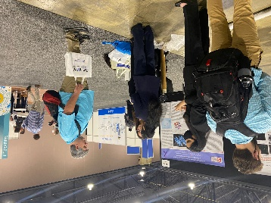Meetings:

* 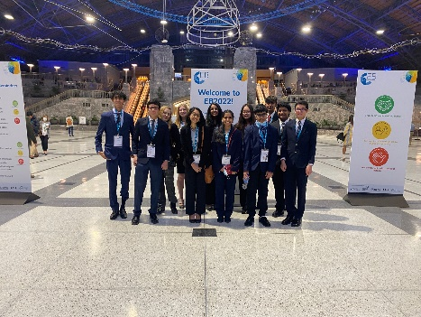**ProMod:** Protein Modeling Teams work with a current research mentor learning about the relationships between structure and function of a protein related to the mentor’s work. The students develop a professional poster and 3D model of the protein, presenting their work at a professional conference in the spring.

Sponsor: Dr. Tina Link

Meetings: Friday 3:30-4:30

**Student Led Competitions**

* **Science Fair (Individual or small group):** Science fair is an opportunity for students to apply the scientific method to conduct independent research. The results of each student's research is presented in a school wide science fair--or sponsored local science fair-- where the student's efforts are displayed and where students are interviewed to determine scientific merit. Students who have been judged to have used the scientific method properly and who have demonstrated thoroughness in their studies and effort are awarded prizes and are advanced to compete in regional, state, national and international science fairs. Preparation for a science fair should begin early in the fall semester with the selection of a topic which will lead to a problem that the student will wish to research.
* **Note:** All students who are interested in conducting scientific research and qualifying for regional or statewide science and engineering fairs must follow the International Rules for Pre-College Science Research. Proper protocol and prior approvals will be required for all students to be eligible to compete at affiliated regional fairs across the state and GSEF.

Coordinator: Ms. Hendricks

The following is a list of competitions that have a diverse set of requirements. If something sounds interesting, look up additional information on the competition’s website. Requirements, dates, etc. will be found there.

(<https://blog.collegevine.com/8-engineering-academic-competitions-for-high-schoolers/>)

* [**The Clean Tech Competition**](https://www.cstl.org/cleantech/log-inregister/): The Clean Tech Competition allows teens to learn about environmental preservation and develop technologies that could help preserve Earth’s natural resources. This national competition involves intensive research into a specific environmental issue, designing an innovative solution, and presenting this solution in the form of a paper and prototype. All registered high school students are encouraged to apply.
* **Marine Advanced Technology Education (MATE) International ROV Competition:** The MATE International ROV Competition gives student exposure to STEM, engineering, and robotics by allowing them to experiment with and develop underwater robotics technologies. Students are given a specific underwater robotics challenge whose difficulty is based on their age. They will build an ROV (remotely operated vehicle) demo and submit it to a regional competition in their area. Any student, whether in kindergarten, middle school, high school, or college, may apply.
* **NASA Human Exploration Rover Challenge:** This is an annual challenge put on by the National Aeronautics and Space Administration (NASA) to get young people involved in developing the next generation of space travel technology. This competition allows high school students to design, develop, and test technologies that could operate and fulfill specific functions in simulated extraterrestrial environments.
* **Rube Goldberg Machine Contest:** This is a more lighthearted competition for students who have a capacity to take ordinary household items (junk, as they call it) and turn them into hilarious machines that perform simple tasks. This competition is inspired by the cartoons of Rube Goldberg and is designed for students 18 years or younger. There are local versions of the Rube Goldberg Machine Contest and a national competition for the local winners.
* **Solar Car Challenge:** This competition is unique in that it teaches students while they are competing. Students who participate in the Solar Car Challenge go through six on-site, national teaching workshops, an intense curriculum, and summer camps that teach them about the engineering of solar cars. The end of the educational experience allows students to race their solar cars and display their creativity to the country. In order to participate, you need to be a registered high school student, and your high school needs to participate in the Solar Car Challenge Program. If that is the case, you have multiple opportunities to learn and compete on the local, regional, and national level.
* **SourceAmerica Design Challenge:** The SourceAmerica Design Challenge allows high school and college students to help people with disabilities succeed in the workplace. In the competitions, you will be matched with a company that helps disabled individuals find employment, or with a disabled employee to learn about their struggles in the workplace. The challenge is then to design an innovative solution that helps them to overcome workplace obstacles. All registered high school and college students are welcome to participate in this national competition.
* **Team America Rocketry Challenge (TARC):** The Team America Rocketry Challenge (TARC) is the biggest student rocket competition in the United States. It was designed to help the US defense industry develop a more advanced engineering and STEM workforce. About 5,000 students from across the nation compete annually. Every year, the contest rules and challenge changes to encourage a fresh approach to rocket design.
* **The High School Bridge Building Contest:** The High School Bridge Building Contest allows students to dive into the realms of physics and engineering as they design and construct their own model bridge. This competition allows students to get a glimpse of the life of a civil engineer, and participants can even see their designs tested for functionality in the real world. This competition exists on the local, regional, and national level. All registered high school students are encouraged to compete.
* **eCyberMission:**  You can participate in this competition without leaving the house. eCyberMission is a web-based contest in which students use science, math, and technology to solve problems facing their communities. First-place winners receive $1,000 in savings bonds. Grades: 9th Only
* **Generation Nano: Superheroes Inspired by Science:** Superhero movies are enjoying a serious moment. If you love science and never miss a Marvel opening night, Generation Nano’s Superheroes Inspired by Science contest is a perfect choice. This STEM competition invites students to create a new superhero and explain his or her powers using scientific research. Along with a written component, participants submit either a short video or a comic.
* **International Genetically Engineered Machine Competition:**L Of course, you don’t have to be a tech enthusiast to take part in STEM competitions. Designed for students with interested in biology, the iGEM competition has students work in teams to build genetically engineered systems with biological parts called BioBricks. The goal is to create projects that positively contribute to the world.
* **Junior Science and Humanities Symposia (JSHS) Program:** The JSHS program is designed to prepare students for careers in research and development. Sponsored by the U.S. Army, Navy, and Air Force, this competition encourages students to conduct original research related to science, technology, engineering, and mathematics. Students must first participate at the regional level before moving on to the national symposium.
* **TEAMS Competition:** Held annually, TEAM invites students to use their engineering talent to contribute to the community. Working in groups, students complete real-life engineering challenges. The competition includes multiple-choice questions, an essay, and a design-build component.
* **Technology Student Association Competitions:** Also known as the TSA, the Technology Student Association brings together students talented in STEM and invites them to participate in various challenges. Activities include animation, architectural design, board game design, and coding, among others. Along with the chance to develop their technological prowess, students gain the opportunity to network with other emerging leaders in tech.
* **Conrad Spirit of Innovation Challenge:** In this challenge, students work in teams of 2-5 to develop products or services in response to key issues facing people around the world. A multi-step entrepreneurial competition, the Conrad Challenge empowers students to take control of their learning and apply it to real-life situations. Winners are eligible for $15,000 scholarships, laptops, and more.
* **Toshiba/NSTA Exploravision:** Interested in what the future has to hold? Consider ExploraVision’s STEM competition. Working in teams of two to four, students will research a particular technology and assess the ways in which it may impact lives moving forward. Participants are required to write a paper and draw webpages communicating their vision.
* **Regeron Science Talent Search:** The oldest science and math competition specifically for high school seniors. In this competition, students showcase original research in science and math areas. Three hundred semifinalists are awarded $2,000, along with $2,000 to be donated to their high schools to support STEM education. Forty finalists receive an all-expenses-paid trip to Washington, D.C., for the Regeron Science Talent Institute, where they will explain their research to some of the country’s top scientists.
* **Intel International Science & Engineering Fair:** A precollege science competition open to students in grades 9-12. There are 22 different subcategories of STEM fields (see the website for a complete list) in which students may choose to compete. Students must first win local affiliated fairs before competing in regional and national competitions. Six hundred individual awards are given in 1st, 2nd, 3rd, and 4th places of each of the 22 categories, with monetary prizes of $3,000, $1,500, $1,000, and $500 awarded respectively. The top winner of the Intel ISEF receives the Gordon Moore Award, and $75,000, with the next top two winners each receiving a $50,000 award. Additional awards worth approximately $4 million are provided through the Intel ISEF Special Awards program, and include tuition scholarships, summer internships, scientific field trips, and laboratory equipment.
* **Google Science Fair :** An online science and technology competition open to individual students and teams comprised of students ages 13-18. Students compete in regional competitions across the world, and 16 global finalists will travel to Google’s headquarters in Mountain View, California to present their projects to the judges. All 16 finalists receive a variety of swag, including magazine subscriptions (check the website for more details on the prizes).
* **Imagine Cup :** Sponsored by Microsoft, the competition is open to students who are at least 16 years old and enrolled as a student in a secondary school. Participants build software using Microsoft technology and tools. Students may enter as teams of up to three participants.
* **Siemens Competition in Science, Math, and Technology:** promotes intensive research “that improves students’ understanding of the value of scientific study and informs their consideration of future careers in these disciplines” for high school students.
* **First Tech Challenge:** Open to students in grades 7-12, this is a competition in which teams comprised of at least 10 members design, build, program, and operate robots to compete in a challenge. The competition awards one top award and one finalist award, as well as several smaller awards for criteria such as motivation and inspiration.
* **Stemanities Research Competition:** A national competition, this event invites students to conduct research in STEM and the humanities to develop a more sophisticated understanding of a topic. Stemanities is sponsored by the Institute for Biomedical Sciences, and finalists are invited to La Jolla, California to present their work and compete for monetary awards.

*Competitions collected from the following sites and are subject to change:

<https://blog.collegevine.com/prestigious-stem-competitions-for-high-school-students/>

<https://blog.collegevine.com/8-stem-competitions-for-high-schoolers/>

<https://blog.collegevine.com/11-academic-competitions-to-boost-your-high-school-profile/>

Appendix E

Internships

Internship: Students must complete a 40-hour STEM related internship between junior and senior year. Internships prior to this time do not count as the required internship but are considered as valuable student growth opportunities.

The requirements can be fulfilled in a variety of ways: Governor’s Honors Program – in a STEM field, a STEM related summer camp, a STEM class at a university, shadowing a professional in a STEM field, and research with a mentor (such as working with a university professor). This list does not include all possible options. If a student has an idea that is not listed above, they may talk with the director to determine if the opportunity meets the requirements of the STEM academy.

Once completed, students need to *fill out the verification form located on the CTLS STEM* site. This is the student’s responsibility. Failure to do so may jeopardize the student’s ability to graduate with the STEM designation. The information needed is as follows:

Name_________________________________

Pathway_______________________________

Expected year of graduation________________

Title of internship________________________________________

Description of internship _______________________________________________________________________________________________________________________________________________________________________________________________________________________________________________________________

Location_______________________

Hours logged____________________

Supervisor_______________________

Supervisor’s email_______________________

Appendix F

**STEM Academy Probation Form**

Student Name (Print): ____________________________________________

Grade Level: ____________

Date: ____________________

Academy Pathway (circle one): AMS | BMS | ENG

Course (if Academic Probation): _____________________________ Course Average _______________

Violation (if Honor Code/Code of Conduct Probation): _________________________________________

Probation Number (circle one): First | Second

**Academic Performance Probation**

* The student has received a grade of D or below in a STEM Academy course.
* Academic probation will continue through the following semester.
* The student must achieve a grade of C or higher in all STEM Academy courses during the probationary semester to remain in the program.

**Honor Code / Code of Conduct Probation**

* The student has committed a violation of the STEM Academy Honor Code or Code of Conduct.
* Honor Code / Code of Conduct probation will remain in effect for the remainder of the student’s time in the STEM Academy.
* Any further violations will result in removal from the program.

## Program Policy

* A student may only be placed on probation two times during their four years in the STEM Academy.
* A third infraction, whether for academics or conduct, will result in removal from the program.

**Expectations**

* The student must maintain appropriate academic standing and/or adhere to the STEM Academy Honor Code and Code of Conduct.
* The student must actively participate in classes, attend regularly, and uphold the standards of the STEM Academy.
* Failure to meet these expectations will result in removal from the STEM Academy.

## Acknowledgement

By signing below, I acknowledge that I have read and understand the terms of this probation, and that I accept the responsibilities outlined above.

Student Printed Name: __________________________________________________

Student Signature: ___________________________________________________ Date: ___________

Parent/Guardian Printed Name: ________________________________________

Parent/Guardian Signature: ____________________________________________Date: ___________

STEM Academy Director Signature: ______________________________________ Date: ___________