

STEM ACADEMY

***Science, Technology, Engineering, Mathematics***

# “Somewhere something incredible is waiting to be known.”

-Carl Sagan

**Engage Inspire Empower**

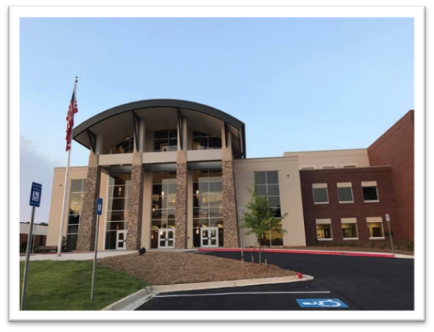

**2025-2026**

*Meeting the Challenge of Excellence for the 21st Century*

**Walton High School**

**1590 Bill Murdock Road**

**Marietta, GA 30062**

***For more information:***

**Visit our website** [**www.waltonhigh.org**](http://www.waltonhigh.org)

**Dr. Tina Link, Director of the STEM Academy**

[**Tina.link@cobbk12.org**](mailto:Tina.link@cobbk12.org)

**Mr. Joe League, Admissions Coordinator**

[**Joseph.league@cobbk12.org**](mailto:Joseph.league@cobbk12.org)

**Ms. Tobie Hendricks, Community Outreach Coordinator**

[**Tobie.hendricks@cobbk12.org**](mailto:Tobie.hendricks@cobbk12.org)

Stem Academy Mission

Foster student curiosity in science, technology, math, and engineering, to cultivate joy in learning and build the confidence to engage as ethical leaders capable of addressing the world’s most significant issues.

Statements of Purpose

* To develop strong interpersonal, communication, research, and technical skills necessary to compete in an ever-changing global society.
* To establish high academic, social, and ethical expectations.
* To foster mastery of both knowledge and skills utilizing innovative resources and authentic experiences.
* To collaborate and cooperate locally and globally within the STEM community.
* To build partnerships with community stakeholders which will strengthen our program and enhance the lives of our students.

Program Description

The Walton High School Science, Technology, Engineering and Mathematics (STEM) Academy offers students a rigorous curriculum driven by problem solving and discovery in a student- centered environment. In accordance with the Georgia Department of Education STEM goals, the Walton STEM Academy will:

* Instruct through rigorous and relevant curriculum
* Empower students to become innovators and technologically proficient problem solvers
* Ensure that all students have access to the appropriate technology conducive to enhancing their STEM learning experiences both in and outside the traditional classroom
* Nurture partnerships that allow schools and the business sector to join efforts to improve students’ STEM-career opportunities
* Increase the number of students pursuing careers in STEM-related fields and/or post-secondary STEM related education/training

The Walton STEM academy is designed for students who have a desire and passion to pursue one of three majors: Advanced Science and Mathematics, Biomedical Science, or Engineering. Students accepted to the STEM academy will take 4 years of their major along with 4 honors and/or AP science courses.  Additional STEM requirements include:

* 9th **and** 10th grade: involvement in a school sponsored individual or group STEM related competition. For example, HOSA, Math Team, Science Olympiad, and Robotics
* 11th grade: a 40-hour internship in a STEM related area. This could include a camp, Governor’s Honors Program (GHP), shadowing a professional, etc.
* 12th grade: students must take part in a cumulative research project from the perspective of their major. The senior Engineering Design and Development course for engineering and the senior Biomedical Innovation course for the biomedical pathway fulfill this requirement. The advanced math and science students can fulfill this requirement either with an independent research project, to be approved by the AP Biology instructor, or taking the AP Capstone sequence of two courses which culminates with AP Research.
* Required attendance at Lunch and Learns. (Approximately two per semester, all four years)

Students are admitted into the specific STEM academy major in their freshman year.  Acceptance of admission into Walton’s Science, Technology, Engineering and Mathematics Academy implies that a student will remain an Academy student throughout their high school career in order to earn STEM designation on their Walton diploma. Special sections of STEM classes are hand-scheduled for students to obtain the best possible scenario for success. Teacher allotments do not allow for flexibility once courses are established. So please make your considerations carefully and submit an application if you are genuinely serious about your major.

Each major within the STEM Academy focuses on a particular interest of the student; therefore, the admission standards and course sequences differ. The following provides information regarding expectations of each major.

Advanced Mathematics and Science

The Advanced Mathematics/Science student is curious about math and science beyond the classroom. The student is able to see relationships between and among topics intuitively and recognizes the symbiotic relationship between math and science. The student has a strong work ethic and understands that teamwork is an essential part of success because the creative minds of many outperform the individual.

*Students who wish to apply to the STEM Advanced Mathematics/Science Academy must be recommended for an Enhanced math and Honors level Science.* ***Please Note****: Summer credits between 8th and 9th grade will not modify your eligibility for admission.* Students accepted in this major will take 4 years of advanced Mathematics and 4 AP Science courses. The following information table outlines the projected Advanced Mathematics/Science courses. *This table serves as a guide to inform students and parents of the general course direction to achieve the STEM Advanced Mathematics/Science endorsement and is subject to change in order to accommodate the needs of the school and personnel.*

|  |  |  |  |
| --- | --- | --- | --- |
| 9th Grade | 10th Grade** | 11th Grade | 12th Grade |
| STEM Enhanced Mathematics | STEM AP Precalculus BC* | STEM AP Calculus BC* | Multivariable Calculus or Distance Calculus with Georgia Tech |
| STEM AP Environmental Science | STEM AP Chemistry | STEM AP Physics C | STEM AP Biology |
|  |  | AP Seminar | AP Research*** |

*Students are encouraged to take AP Statistics as an additional class during 10th or 11th grade.

**Students will have the option of signing up for STEM AP Computer Science in the 10th grade with the objective of taking three years of AP and post-AP Computer Science courses.

***Students will complete the senior research project as part of this course.

Engineering

The Engineering student has a natural curiosity for how things work. The student is able to apply creative solutions to problems that may not have concrete answers. The engineering student enjoys math and science and seeing how these subjects apply to problems. Additionally, the student understands that brain power alone is not enough to be a successful engineer and student, but hard work in class and meeting assignment deadlines is essential. The student must understand that teamwork is an essential part of engineering because the creative minds of many outperform the lone genius. The engineering student is enthusiastic about engineering whether it is for one particular field or the aspect of problem solving as a whole. The Engineering courses use Project Lead the Way curriculum which is national recognized for excellence.

Students who wish to apply to the STEM Engineering Academy must be recommended for at least GSE Honors Algebra and Honors level Science. Students accepted in this major will take 4 years of Engineering courses and 4 honors & AP Science courses. The following information table outlines the projected courses for an Engineering major. *This table serves as a guide to inform students and parents of the general course direction to achieve the STEM Engineering endorsement, and is subject to change in order to accommodate the needs of the school and personnel.*

|  |  |  |  |
| --- | --- | --- | --- |
| 9th Grade | 10th Gradeǂ | 11th Gradeǂ | 12th Grade |
| PLTW Introduction to Engineering Design | PLTW Principles of Engineering  *Optional: STEM AP Computer Science | PLTW Aerospace Engineering or PLTW Digital Electronics (course alternates every other year) | PLTW Capstone: Engineering Design and Development** **and** STEM Advanced Scientific Research IV*** |
| STEM Honors Biology | STEM Honors Chemistry | STEM AP Physics 1/C: Mechanics | STEM AP Physics C: Electricity and Magnetism |

*Students will have the option of signing up for STEM AP Computer Science in the 10th grade with the objective of taking three years of AP and post-AP Computer Science courses.

**Students will complete the senior research project as part of this course.

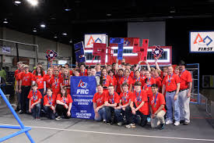***Students will receive two credits for this course. Students will receive a credit for PLTW EDD and a credit for STEM Advanced Scientific Research IV, a post Advanced Placement. Research IV is a post Advanced Placement class embedded in the capstone course and students will receive an extra quality point in their GPA based on their PLTW capstone grade.

ǂ Students are encouraged to take AP Statistics as an additional class during 10th or 11th grade.

Biomedical Science

The biomedical student has as interest in pursuing a career within the medical field.  Because of the embedded on- and off-campus internship opportunities within this pathway, the foundation of this interest is based on the student’s enjoyment in helping people.  The biomedical student must be responsible and motivated by knowing they can make a difference in the lives of others.  The student must be able to work independently and as a team member in promoting health and wellness.  The student must be able to both think critically and to formulate a solution or series of solutions related to various health issues.  The biomedical student is excited about medicine, how it changes and the endless possibilities of new discoveries.  The Biomedical Science courses use Project Lead the Way curriculum which is national recognized for excellence.

Students who wish to apply to the STEM Biomedical Science Academy must be recommended for at least GSE Honors Algebra and Honors level Science.  Students accepted in this major will take 4 years of biomedical science courses and 4 honors & AP Science courses.  The following information table outlines the projected courses for a Biomedical Sciences major.  *This table serves as a guide to inform students and parents of the general course direction to achieve the STEM Biomedical Sciences endorsement, and is subject to change in order to accommodate the needs of the school and personnel.*

|  |  |  |  |
| --- | --- | --- | --- |
| 9th Grade | 10th Gradeǂ | 11th Gradeǂ | 12th Grade*** |
| PLTW Principals of Biomedical Science | PLTW Human Body Systems **and**  Honors Human Anatomy***  *Optional: STEM AP Computer Science | PLTW Medical Interventions | PLTW Capstone: Biomedical Innovation** **and** STEM Advanced Scientific Research IV. |
| STEM Honors Biology | STEM Honors Chemistry | STEM AP Biology | STEM AP Physics 1 |

*Students will have the option of signing up for STEM AP Computer Science in the 10th grade with the objective of taking three years of AP and post-AP Computer Science courses.

**Students will complete the senior research project as part of this course.

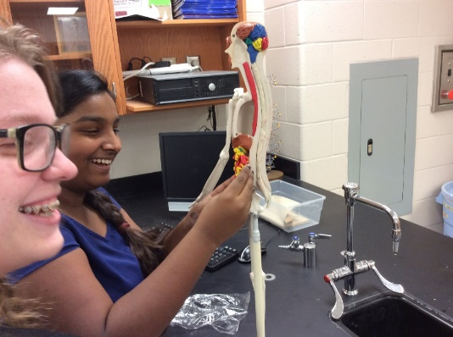***Students will receive two credits for this course. 10th grade: Students will receive an honors credit for the PLTW course and the same grade will also count as Honors Human Anatomy. 12th grade: Students will receive a credit for PLTW BI and a credit for STEM Advanced Scientific Research IV. Research IV is a post Advanced Placement class embedded in the capstone course and students will receive an extra quality point in their GPA based on their PLTW capstone grade.

ǂStudents are encouraged to take AP Statistics as an additional class during 10th or 11th grade.

Extracurricular Requirements

Students in the STEM Academy will be willing to pursue STEM interest through their extra-curricular activities. Individual academic competitions will be embedded in the STEM course work. During the 9th and 10th grade years, students in the STEM Academy will be expected to participate in one team competition activity such as HOSA, Debate Team, Robotics Team, Math Team, Odyssey of the Mind, Science Olympiad, Science Bowl or Academic Bowl.

Summer Commitment

During the summer after 11th grade, students will be expected to participate in a forty-hour enrichment such as a research project, an internship, GHP or camp in the major area. The student must submit his or her proposal in writing to the STEM director for approval.

Optional Activities

Not everything is about work! We believe that it is important to provide opportunities for students to mingle and relax. Here are just a few examples of what we do!

* Tremont – fieldtrip for Freshman
* Breakfasts – a couple of times each semester
* Potluck- in the fall (for the students and their families)
* Picnic- in the spring
* International trips
* Participate in middle school STEM night

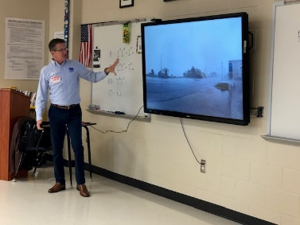

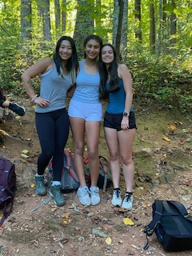

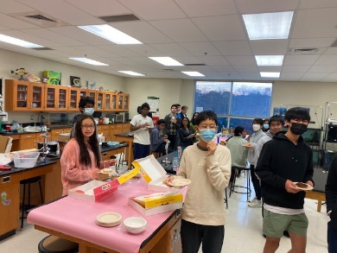

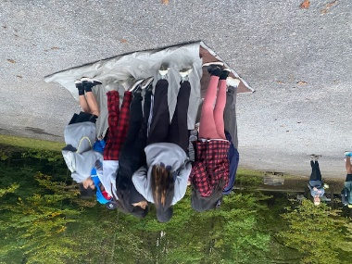

Admission Requirements and Application Process

*Applicants of the graduating class of 2028 must reside within the Walton High School attendance zone****.*** *The admissions committee will consider the candidates based on: information in application package, strong middle school grades, teacher recommendations, attendance, Readistep or ACT or SAT scores if available, mathematics and science grades in middle school, and desire in the major area.*

1. Complete the online application located on this page.
2. Teacher recommendation will be sent automatically once the application has been submitted.
3. If outside of the Cobb County School District, include a copy of your 7th and 8th grade grades, attendance records, standardized test scores, and SAT score (if applicable) to

Walton High School

attn: Joe League

1590 Bill Murdock Rd.

Marietta, GA  30062

Complete all required sections of the on-line application form by the deadline of December 19th: In order for all of your paperwork to be in by the deadline, completing the on-line application prior to the deadline will give the teachers more time to complete the recommendations.

Important Dates and Timeline

Nov. 12, 2025 Informational meeting, 6:30 pm, Theater

December 19, 2025 Applications due to Walton High School

January 9, 2026 Students outside CCSD submit report cards

February 6, 2026 Admission decision mailed to applicants

February 26, 2026 FAQ night 5:30-6:30 pm

March 2, 2026 Intent letters due back by accepted students

**Walton High School**

**STEM Academy**

FAQs:

*What if more than one major holds interest for me?*

It is important to apply for the major in which you are most interested. If you are sincerely interested in two different majors, you will need to complete separate applications for each major. The selection committee will independently consider your application in each major.

*Is the STEM Academy right for me?*

Only you will be able to answer this question. If you are looking for a program that is academically rigorous, are passionate about your major, and are interested in focusing your extracurricular time on your major, then this would be a good experience for you. After attending our information night, discuss your interest with your family.

*Will I have any flexibility in choosing my courses?*

You will have a prescribed course of study in your major, and you will also be registered for certain courses required for high school graduation that are aligned with the STEM program. These courses will include instruction focused on STEM and problem solving. You will be required to take the designated STEM courses each year.

*What if I am a member of the band, chorus or the orchestra?*

You will need to carefully plan your schedule to accommodate the requirements of the STEM major as well as the music programs. You will not be able to substitute any of the cohort STEM courses which limits scheduling ability. You will be eligible to add a tuition course (zero period) to meet the STEM classes if necessary. You will be able to speak with a Guidance Counselor or member of the STEM faculty for advisement with regard to your course schedule.

*What if I don’t think I can be successful in Honors or AP level courses, then what?*

The rigor of the curriculum is different depending on the major. We believe all students should take at least one AP exam before graduating from high school, but if you are concerned looking at the expectations then you should probably not apply to the STEM Academy. Take into consideration that added support will be provided by the STEM faculty to help you as you pursue a more project-based curriculum. Students will only be eligible if they are recommended for the level of course required by the major. No waivers will be accepted to meet this requirement. Challenge yourself! You are not alone.

*Can I drop out of the Academy?*

By recommendation of the STEM faculty and/or the student’s Guidance Counselor, or in extreme cases in consultation with the parents and teachers, students may be released from the STEM academy. Special sections of STEM classes are hand-scheduled for students to obtain the best possible scenario for success. Teacher allotments do not allow for flexibility once courses are established. So please make your considerations carefully and submit an application if you are genuinely serious about your major.

*I f I don’t apply now, can I apply in my sophomore or junior year?*

No. Applications are taken for entering freshmen only.

*What costs are associated with the STEM academy?*

This will vary based on the choices you make for extracurricular and summer requirements. The STEM faculty will work with you to find affordable options for both. While not a requirement, we do ask for an annual $100 donation which helps fund our lunch and learns, project materials, etc. This tax-deductible donation can be made through the STEM website. Additionally, while not a requirement, students are strongly encouraged to have an iPad or laptop for use in the classroom.

*How does the STEM Academy differ from a magnet?*

The STEM Academy students are part of a cohort only for the two designated courses each year. This allows your child to be part of all the other opportunities Walton High School offers at a variety of levels of academic rigor. Also, the STEM Academy majors have different pre-requisites thus enabling students to be part of this program in their specific area of interest.

*What’s in it for me?*

* Hard, challenging work toward a STEM Academy endorsement
* The chance to learn through a *project-based* curriculum that focuses on the connections between Science, Technology, Engineering and Mathematics
* Expanded opportunities for authentic learning experiences through Internships
* A unique opportunity to draw attention to your high school transcript in competition for college admissions

